Independent advocacy workbook

How to use the workbook
This work book forms part of the suite of learning materials that have been developed to support the implementation of part one of the Care Act 2014. These materials summarise and explain the ‘Care and Support Statutory Guidance’ (October 2014) [“the guidance”] and are designed to help those involved in care and support services to understand and implement the Act.

The suite of learning materials contains workbooks, PowerPoint presentations and other material for each of the following topic areas:
- Introduction and overview
- Information and advice
- First contact and identifying needs, including assessment and eligibility, and independent advocacy
- Charging and financial assessment, including deferred payment agreements
- Person centred care and support planning, including personal budgets, direct payments and review
- Transition to adulthood
- Integration, cooperation and partnerships

This workbook is about the independent advocacy requirements of the Act and its statutory guidance. It has been written for learning facilitators and includes exercises, suggested group discussions, points of reflection and case studies that facilitators can use either in their entirety or to pick and choose from as they see fit when designing a learning programme based on the PowerPoint presentation.

The workbook can also be used by individuals who wish to learn more about this topic area. You can watch the presentation, read the notes below, and undertake the exercises at a pace and time to suit you.

As well as this workbook and PowerPoint presentation, there are also handouts and a shorter, overview presentation on this topic area. Handouts provide easy to print resources that summarise key factual information from the guidance.

The implementation of the Act requires whole systems change and underpinning this is a need for cultural change. These learning materials alone will not affect such change, but they are one tool that can be used to support people along the journey. In many instances, implementing the Act successfully will require those involved in the care and support system to change the way they work i.e. behaviour change. Research suggests that the way people behave is influenced by their knowledge, skills and attitudes:
Behaviour
The PowerPoint presentation and handouts are designed to increase knowledge about the Act or guidance. The questions and exercises in the workbook are designed to spark conversations that encourage people to reflect on their own attitudes and the attitudes of others. They aim to give learners the opportunity to discuss the complexities of implementing the changes in practice, and/or provide a safe way of challenging attitudes that go against good practice. The case studies are designed to provide an opportunity for people to analyse and practice their skills.

Key learning point
These are used in the workbook as a way of highlighting changes that are likely to have a significant impact on practice i.e. the major changes that the Act brings in.

The facilitators’ hints and tips in the workbook signpost facilitators to existing good practice resources on this topic area and/or highlight key changes that are likely to have the most significant impact on practice. The aim is to help facilitators to design interactive learning programmes that are appropriate for their audience.

Facilitator’s hints and tips
To successfully facilitate this module we suggest that you need to:
  - have read the relevant sections of the Act, regulations and guidance
  - have a good understanding of best practice in this topic area
  - remember that there are various modules available and you need to choose the most suitable ones for your learning programme
  - also remember that you can pick and mix questions, exercises and case studies from this workbook or from other topic areas
  - design your training session in a way that accounts for the learning pyramid so as to maximize the experience and learning outcomes for your participants.
Average retention rates

Passive teaching methods
Participatory teaching methods

Source: Adapted from National Training Laboratories, Bethel, Maine

Who is it for?

This workbook is about independent advocacy. It explores sections 67-68 of the Care Act and chapter 7 of the statutory guidance. It is intended to be used to develop learning programmes for:
- people who have a responsibility for identifying the need for, and arranging for, an Independent Advocate to facilitate the involvement of a person
- people employed as Independent Advocates (including Independent Mental Capacity Advocates)
- managers of all of the above types of roles.

Contents

The workbook starts with an overview, which summarises the topic area, and identifies relevant key words. It then contains the following sections that match the slides in the PowerPoint presentation:
- Introduction
- What is independent advocacy under the Care Act 2014?
- Interface with the Mental Capacity Act 2005
- When the Care Act independent advocacy duties apply
- Summary
Appendices: links to key resources; handouts

Overview

Local authorities must involve people in decisions made about them and their care and support. Involvement requires the local authority helping people to understand how they can be involved, how they can contribute and take part and sometimes lead or direct the process. People should be active partners in the key care and support processes of assessment, care and support planning and review, or safeguarding. The duty to involve applies in all settings, including those people living in the community and in care homes, and also in prisons for example.

The aim of the duty to provide independent advocacy is to enable people who have substantial difficulty in being involved in these local authority processes to be supported in that involvement as fully as possible, and where necessary to be represented by an advocate who speaks on their behalf. The Care Act defines four areas in any one of which a substantial difficulty in being involved might be found:
- understanding relevant information
- retaining information
- using or weighing up the information
- communicating their views, wishes and feelings

In general, a person who has substantial difficulty in being involved in their assessment, plan or review, will only become eligible for an independent advocate where there is no one else appropriate to support their involvement. However, the provision of an advocate, even where they have family or others who can facilitate the person’s involvement, may be required by the Care Act and appropriate in certain circumstances, for example where they are at risk of harm. There is also a separate duty to arrange an independent advocate for adults who are subject to a safeguarding enquiry or safeguarding adults review (SAR).

The Care Act places a duty on local authorities to provide an information and advice service that is available to all people. Prior to an assessment with the local authority, there may be some people who require independent advocacy to access information and advice. Local authorities will need to consider such needs in ensuring that the information and advice service is accessible.

The Care Act extends the range of situations and people to whom there is a duty to make advocacy available. Nothing in the Care Act prevents advocacy being provided in other circumstances.

Independent advocates have two main functions: to support the person to make their own decisions and be as involved as possible; and to represent them, which may involve speaking on their behalf. The independent advocate must ‘advocate’ on the person’s behalf, to put their case, to scrutinise the options, to question the plans if they do not appear to meet all eligible needs or do not meet them in a way that fits with the person’s wishes and feelings, or are not the least restrictive of people’s lives, and to challenge local authority decisions where necessary. The ultimate goal of this representation is to secure a person’s rights, promote the person’s well-being and ensure that their wishes are taken fully into account.

The local authority is expected to recognise that an advocate’s role incorporates challenge on behalf of the person, and the local authority must take into account any representations made by an advocate. The local authority should take reasonable steps to assist the independent advocate in carrying out their role.

Key words

The suite of learning materials contains a glossary of key words used in the statutory guidance. The following key words are relevant to this topic area: appropriate individual, assessment, care and support plan, eligible needs, independent advocate, lack of capacity, outcomes, safeguarding, substantial difficulty, supported decision making, support plan, transition, wellbeing.

Introduction
Slide 1

Notes
- This presentation forms part of the suite of learning materials that have been developed to support the implementation of part one of the Care Act 2014. These materials summarise and explain the ‘Care and Support Statutory Guidance’ (October 2014) and are designed to help those involved in care and support services to understand and implement the Act.

- This presentation is about independent advocacy. It is intended for:
- people employed by local authorities who have a responsibility for identifying the need for, and arranging for, an advocate to facilitate the involvement of a person as specified in the Act
- staff employed as Independent Advocates (including Independent Mental Capacity Advocates)
- managers of all of the above types of roles.

- The aim of the presentation is to help you reflect on the implications of the Act for your role, so that you will know what you must do differently and what you may need to do differently.

Slide 2


Slide 3
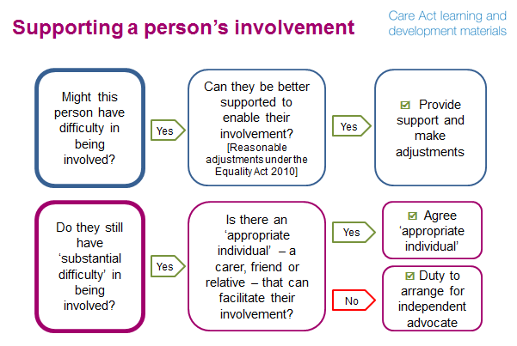
Notes
- The Care Act requires that local authorities involve people in decisions made about them and their care and support or where there is to be a safeguarding enquiry or safeguarding adults review. People should be active partners in the key care and support processes of assessment, care and support planning and review, and any enquiries in relation to abuse or neglect. ‘Involvement’ requires the local authority helping people to understand how they can be involved, how they can contribute and take part and sometimes lead or direct the process. The ultimate aim is for people’s wishes, feelings and needs to be at the heart of these processes.

- Some people may have difficulty in being involved in these processes. The decision pathway in this slide shows two ways in which an individual could be supported if you thought that they might have difficulty being involved.

- Firstly, it is important to establish if and how the person could be better supported by making changes to the arrangements. For example, by providing information in an accessible format and involving an appropriately trained and registered interpreter if the person needs one e.g. if they are a sign language user or don’t have enough English to be involved without an interpreter. Note that local authorities have a duty under the Equality Act 2010 to make reasonable adjustments to meet the needs of people with particular accessibility requirements. Such adjustments should be made before the individual’s ability to be involved in the process is reviewed again.

- However, some people still won’t be able to be involved, even if the process has been adapted to meet their communications needs, because they still have ‘substantial difficulty’ in being involved. We will look at what ‘substantial difficulty’ means in more detail in the next slide.

- Local authorities have a duty to involve people, so if someone has substantial difficulty being involved they must be supported to be involved as fully as possible by either:
- ensuring that there is an ‘appropriate person’ such as a friend or relative who can facilitate their involvement; or
- if there is no appropriate individual to help them, by arranging for an independent advocate to support and represent them.

- We will look at what ‘appropriate individual’ means in more detail at slide 5.

Questions
- What key words or phrases (in the slide) stand out to you? Why?
- What measures do you currently take to meet people’s communication needs?
- What changes might be needed for example to an assessment process to facilitate a person’s involvement?

Key learning point
A local authority must involve an individual in their key care and support processes of assessment, care and support planning and review, or safeguarding.

Slide 4
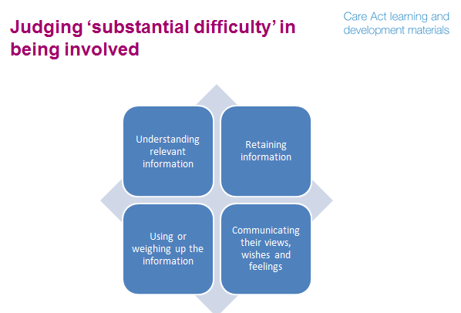
Notes
- Handout: Substantial difficulty

- The Care Act defines four areas in any one of which a substantial difficulty might be found:
- understanding relevant information
- retaining information
- using or weighing up the information
- communicating their views, wishes and feelings

- Many people can be supported to understand relevant information, if it is presented appropriately and if time is taken to explain it. See the information and advice module for more information about accessible information and advice. Some people, however, will not be able to understand relevant information, for example if they have mid-stage or advanced dementia.

- If a person is unable to retain information long enough to be able to weigh up options and make decisions, then they are likely to have substantial difficulty in engaging and being involved in the process.

- A person must be able to weigh up information, in order to participate fully and express preferences for or choose between options. For example, they need to be able to weigh up the advantages and disadvantages of moving into a care home. If they are unable to do this, they will have substantial difficulty in engaging and being involved in the process.

- A person must be able to communicate their views, wishes and feelings - whether by talking, writing signing or any other means - to aid the decision process and to make priorities clear. If they are unable to do this, they will have substantial difficulty in engaging and being involved in the process. For example, some people with mid-stage or advanced dementia, significant learning disabilities, a brain injury or mental ill health may be considered to have substantial difficulty in communicating their views, wishes and feelings. But equally a person with Asperger’s may be so considered, as may a frail older person who does not have a diagnosis but is confused as a result of an infection, or a person who is near the end of their life and appears disengaged from involvement and decision-making. Within this context, it is the person’s ability to communicate their views, wishes and feelings which is fundamental to their involvement rather than the diagnosis or specific condition.

Key learning point
If an individual has substantial difficulty in any one of these four areas then they have substantial difficulty being involved.

Exercise
Describe the factors that you might want to consider when judging if someone has substantial difficulty in being involved. How might you get the information you need to make that judgement?

Suggested answer
- Every individual is unique and you need to take account of the particular situation, the whole person and their needs. Remember that your judgement is about whether they have substantial difficulty in being involved in the particular process which is to take place (assessment, planning, review and safeguarding) – so you need to establish this to your satisfaction on the information available to you, but not to prove conclusively that they definitely do have a difficulty. The factors involved in this judgement need to focus on a could be any combination of intellectual, physical, emotional, psychological or sensory, and some of the questions which you need to consider are whether the individual is able to:
- answer the questions you need to ask
- make clear that they understand who you are and what your role is
- make clear to you that they understand their situation
- tell you how they feel about their situation
- show you that they understand what you have told them
- recall information or decisions that were shared in any previous meeting
- fully able to describe the options available to them
- describe the possible outcomes of any choices they make
- describe their preferences to you.

If a person is having difficulty with any one of the areas of understanding, retaining or weighing information or communicating their views wishes and feelings then that would indicate that they are having substantial difficulty in being involved. However, you need to establish whether the individual’s immediate situation is particularly unusual or stressful, or whether the difficulty is substantial enough to have an impact on their involvement.

You need to ensure that the substantial difficulty is not caused by external factors that can be addressed. You should do so by resolving these wherever possible. So, for example, you need to make sure that your communication methods offer the person good opportunities to be involved and that any information you share with them is presented in an appropriate format.

You need to make sure that you are making the judgement on the basis of the person’s true responses. So, for example, you need to be clear that they are not inappropriately influenced or interpreted by other people, and that their responses are not affected by fears or threats.

- An important way of getting the information you need to make your judgement is by engaging directly with the person themselves, but there are other sources of information which can help you to get a rounded picture:
- Speaking with family and other people who know the person
- Speaking with other professionals who have worked with the person
- Checking any records or reports or legal judgements relevant to the person

Case study

Mishal is in her early 30’s and was diagnosed with multiple sclerosis four years ago. She lives alone in a ground-floor flat. She works as an administrator but is currently off work having experienced a relapse. She has made a good physical recovery but is concerned that she will not be able to return to work because of the fatigue she is experiencing and also poor concentration and memory problems. She has had previous relapses and remissions, but has always managed to return to work successfully.

She telephones the local council’s information and advice service to find about what help might be available. From what she has read on the Council website she is unsure about whether she will be eligible for anything because she thinks that she might have too much savings.

She tells the information and advice worker that she wants to get back to work but feels that everything is “out of control” and that she can’t concentrate. When it is explained that she will have to have an assessment to determine whether her needs are eligible needs, Mishal becomes very despondent because she was hoping that the information and advice worker would tell her that she would be getting some help. Despite the information and advice worker’s best efforts Mishal does not seem to understand the process of assessment and care and support planning, let alone how financial assessment and charging works. It is suggested that she comes into the information and advice centre for a face-to-face discussion but she says it would be too tiring and stressful and that there is nobody who could help her.

It is agreed that the information and advice worker will get some advice about how to proceed and then telephone Mishal.

Question
- Do you think that Mishal has substantial difficulty in being involved in the assessment process?

Suggested answer
Although Mishal did not understand the relevant information over the telephone, she may well be able to do so with more visual material and careful explanation in person and might not have a substantial difficulty in this respect. The information and advice worker would have had this in mind when inviting her in for a face-to-face discussion. However, there are indications (poor concentration and memory problems) that at present Mishal may be unable to retain information long enough to weigh up options and make decisions, so she may have substantial difficulty in being involved in the assessment process.

As it is clear that Mishal has the ‘appearance of care and support needs’, the assessment should continue, if she is in agreement. The assessment service is to be advised that Mishal may have substantial difficulty in being involved.

It is up to Mishal to identify if she has someone who could support her as an appropriate person. The information and advice worker did not identify anyone who could act as an appropriate individual - the nature of the discussion meant it was not possible to be certain about whether there is someone who can act as an appropriate individual who could facilitate her involvement in the assessment.
The assessment service receives the referral and makes contact with Mishal.

OPTION A
Based on the information they have received from the information and advice worker and Mishal herself, they have evidence that Mishal will need support to understand the information they send out prior to the assessment to help her understand the process, prepare for the assessment and be able to be actively involved. They establish from Mishal that she does not have any one appropriate to support her. The assessment service decides that they will offer Mishal an assessment with the support of an independent advocate and explains to her how an advocate can help.
The role of the independent advocate will be to support Mishal in understanding the pre-assessment information and preparing for the assessment (for example by making sure that she is able to identify what she wants to communicate), supporting her involvement during the needs assessment & financial assessment (for example by ensuring that she is able to say what she wants and that people are taking notice of this), and in understanding the outcome of the assessments. The independent advocate will also support her during the care and support planning process, and also in accessing universal information and advice as this latter objective was not achieved at the point of first contact. It is anticipated that Mishal’s difficulties in retaining information may well be overcome once care and support is provided.

OPTION B:
Based on the information they have received from the information and advice worker and Mishal herself, they have evidence that Mishal will need support to understand the information they send out prior to the assessment to help her understand the process, prepare for the assessment and be able to be actively involved. They establish from Mishal that she has a sister who is close to her, who she sees regularly and has helped her with her affairs in the past. Once contacted her sister is happy to support Mishel’s involvement in the assessment process and Mishel is content with this. The assessment service judge that her sister is an ‘appropriate individual’ to facilitate Mishal’s involvement and proceed with the assessment on that basis.

Slide 5
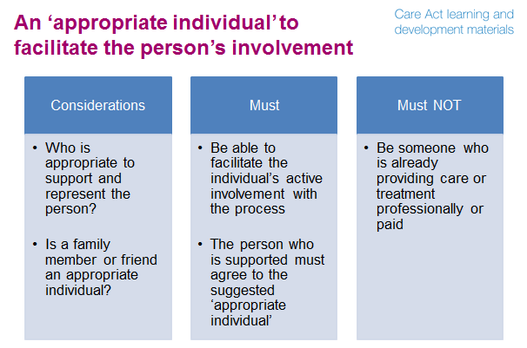
Notes
- If an individual has substantial difficulty being involved in the assessment, planning, review or safeguarding processes, local authorities have a duty to support them to be involved as fully as possible.

- The first thing to consider is whether there is an appropriate individual (or individuals) to support and represent them. An appropriate individual could be, for instance, a carer, friend or relative.

- Only if there is not an ‘appropriate individual’ to support and represent the person does the local authority have a duty to provide an independent advocate.
- What would make somebody an ‘appropriate individual’ under the Care Act? The main thing to consider is whether they would be able to facilitate the person’s active involvement in the process. With the appropriate individual’s support, would the person be able to be an active partner in the process and be involved in decisions made about them and their care and support?

- It is not sufficient to know the person well or to love them deeply – the role of the [appropriate] individual is to support the person’s active involvement with the local authority processes. Some people will not be able to fulfill this role easily, for instance:
- a family member who lives at a distance and who only has occasional contact with the person
- a spouse who also finds it difficult to understand the local authority processes
- a friend who expresses strong opinions of their own prior to finding out those of the individual concerned, or a housebound elderly parent.

- It will clearly not be suitable for a person to be regarded as an appropriate individual where they are implicated in any enquiry of abuse or neglect or have been judged by a SAR to have failed to prevent an abuse or neglect.

- The person’s wishes must be respected. If they don’t want to be supported by a particular relative, for example perhaps because they wish to be moving towards independence from their family, then the local authority cannot consider that relative appropriate. The person’s wish not to be supported by a particular individual should be respected and if the person has capacity, or is competent to consent, the person's wishes must be followed. If the person lacks the capacity to make a decision, then the local authority must be satisfied that it is in their best interests to be supported and represented by that individual.

- An appropriate individual cannot be someone who is already providing the person or their carer with care or treatment in a professional capacity or on a paid basis. It cannot be, for example, a GP, or a nurse, a key worker or care and support worker.

- There may also be some cases where the local authority considers that an person needs the support of both a family member and an advocate; perhaps because the family member can provide a lot of information but not enough support, or because while there is a close relationship, there may be a conflict of interest with the relative, for example in relation to inheritance of the home.

- Sometimes the local authority will not know at the point of first contact or at an early stage of the assessment whether there is someone appropriate to facilitate the person’s involvement – as in the Mishal case study. They may need to appoint an advocate, and find later that there is an appropriate person in the individual’s own network. The advocate can at that stage ‘hand over’ to the appropriate person. Equally, it is possible that the local authority will consider someone appropriate who may then turn out to have difficulties in supporting the individual to engage and be involved in the process. The local authority must at that point arrange for an independent advocate.

- If the local authority decides that they are required to appoint an independent advocate, as the person does not have friends or family who can facilitate their involvement, the local authority must still consult with friends or family members when appropriate. Consult means asking their views.

- It is the local authority’s decision as to whether a family member or friend can act as an appropriate individual and it is the local authorities responsibility to communicate that decision to the person’s friends and family where this may have been in question.

- Note that an ‘appropriate individual’ within the Mental Capacity Act 2005 (MCA) has a different role to that in the Care Act 2014. Within the MCA, the appropriate individual must be appropriate to consult. Under the Care Act an appropriate individual must be able to support and represent the person and facilitate their involvement. It is a far more active role. It requires that the appropriate individual is willing and able to ensure that the person undergoing the local authority process is themselves involved rather than the appropriate individual merely commenting on their behalf.

Key learning point
The role of an ‘appropriate individual’ is to facilitate the person’s active involvement.

Example
Jacinta is 26 and lives with her mother and father. She has 2 siblings aged 28 and 23 who have left the family home. Jacinta would also like to move to living more independently. Jacinta has moderate learning disabilities and finds it hard to retain information. She can look after her personal care needs, and has some very basic cooking skills but is very poor with money. Jacinta’s parents are known to be protective and are dead set against her moving. They are adamant that it is their responsibility to look after her, that she won’t be able to cope living on her own and that she will be lonely and vulnerable. In these circumstances Jacinta’s parents may not be an ‘appropriate individual’ who could effectively represent and support her interests.
Questions
- Using your experience, can you think of a person who has family, friends or others who would want to represent them, but who might not be an ‘appropriate individual’?
- Why might they not be appropriate?
- How would you handle the situation?

Case study
Adam is 47 years old and has a diagnosis of moderate/severe learning disability and has been using care services since he was a child. He attended a special needs school throughout his education and remained at school until he was 19 years old.
He lives in supported living accommodation, works at a community café, and attends the local college once a week. He is in regular contact with his sister who lives nearby.

When his eligibility was last considered (prior to the implementation of the Care Act) his needs were in the substantial band of the Fairer Access to Care Services (FACs) eligibility criteria.

Adam suffers with arthritis and often has pain in his joints and gets very tired easily. He needs support to make sure he remembers to take his medication regularly. He can often become upset and agitated over different things and will lose his temper and throw/break objects or become verbally aggressive. These incidents are increasing in their frequency and recently there have been occasions when he has become anxious and staff have had to leave him in his flat until he has calmed down to prevent themselves from getting hurt.

These incidents have focused on keeping his room clean. He hides away uneaten food and rubbish which sometimes remains undiscovered until it starts to smell. Adam doesn’t acknowledge this as a problem, and gets angry when the cleaners discover the food and also when his key worker tries to talk to him about it. It is a condition of his tenancy agreement that a reasonable standard of cleanliness is maintained.

His sister Alice thinks it is the cleaners that he has that are the problem, because they do not communicate with him sensitively. She wants Adam to have a direct payment so he can employ his own cleaner. The manager of the supported living accommodation believes that the problem needs further consideration before a way forward can be found.

Questions
- Do you think that Adam has substantial difficulty in being involved?
- What would you do about Alice’s request for a direct payment for a cleaner?
- If it was decided that Adam did have substantial difficulty in being involved should he have an independent advocate?

Suggested answer
- There is evidence that Adam has substantial difficulty in communicating his views, wishes and feelings to the extent that they are inhibiting his involvement in decisions that need to be made about the management of his care and support. It is possible that he also has substantial difficulty in the other three areas set out in the guidance of understanding relevant information, retaining information and using or weighing the information as part of engaging, but further exploration would be needed to determine this. However, it is only necessary for one of the four areas to be demonstrated to conclude that there is substantial difficulty.

- The response to Alice’s request for a direct payment must be considered and this would probably be best achieved through a review of his care and support plan. The local authority must make the judgement about whether Adam has substantial difficulty in being involved at this point. It may be the case that the local authority has outsourced reviews or commissioned the care provider to hold them. However, whatever the circumstances the local authority retains the overall responsibility for this judgement.

- In general, an individual who has substantial difficulty in being involved will only qualify for an independent advocate where there is no one appropriate to support their involvement. Therefore, the local authority must decide whether Alice can act as an appropriate individual to facilitate Adam’s involvement. If she can take on this role then an independent advocate would not normally be appointed. The appropriate individual is expected to support and represent the person and to facilitate their involvement in the processes. So having established that Adam is happy for Alice to support him (assuming he has capacity and that he does), the local authority would have to be satisfied that she understands that it is her role to support his active involvement. In this case the local authority may decide that Alice cannot take on this role her opinion about the direct payment to employ a cleaner gets in the way of her supporting Adam to say what he wants and representing his views.

What is independent advocacy under the Care Act?
Slide 6
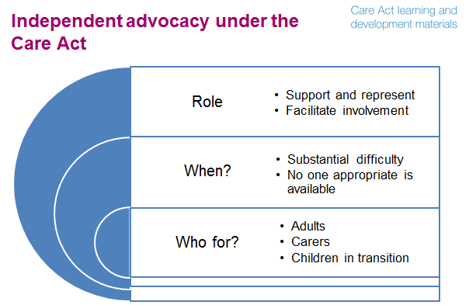
Notes
- Who might need independent advocacy? The duty to provide independent advocacy applies to:
- adults who need care and support
- carers of adults and carers of children in transition
- children who are approaching the transition to adult care and support, when a child’s needs assessment is carried out, and when a young carer’s assessment is undertaken.

- When might those people need independent advocacy? Whenever they would otherwise be unable to be involved in the key processes. The local authority has a duty to arrange for an independent advocate to support and represent someone when these two conditions are met:
- the person has substantial difficulty in being fully involved in the key care and support processes of assessment, care and support planning and review, or safeguarding, and
- there is no one appropriate available to support and represent their wishes.

- The role of the independent advocate is to:
- support and represent the person in these key processes
- facilitate the person’s involvement in the key processes and interactions with the local authority.

Key learning point
The duty to provide independent advocacy applies to adults, carers and children in transition.

Exercise
List and describe in what situations you would consider independent advocacy to be needed by someone with substantial difficulty rather than having an appropriate person. Explain how you might go about making this judgement.

Suggested answer
- The first situation would be where the individual has no one who they want or who they know could support and represent them and could facilitate their involvement. For example, this might include situations where they no longer have any family or friends, or a situation where they do not trust family or friends to represent them properly.

A second situation would be where an individual’s trusted friends who could play the role of appropriate individual are already providing professional or paid care to them. For example, a long standing home care provider, or therapist, might be someone the person would normally look to, but in this circumstance they would need to end their professional or paid involvement with the person if they were to undertake the appropriate person role.

A third situation would be where the person has a relative or friend who could in principle play the role, but for logistical or capacity or ability reasons would be unable to undertake the tasks involved. For example, it might be that a close family member living in another country would be unable to visit frequently enough to support the person’s involvement. Alternatively, someone living nearby who would be suitable might be ruled out because their personal circumstances mean they cannot give the time to the role. It may also be that a close friend of the person would not be suitable because they do not have the intellectual, emotional or physical capacity to take on the task.

Fourthly, it may be that you would not be confident that the proposed appropriate individual would represent and support the person properly and actively facilitate their involvement.

- Making this judgement is not easy. It will need to involve the person being supported and the potential appropriate individual. You will need to:
- be clear about the role and likely tasks involved for the appropriate individual or independent advocate
- establish whether there might be an appropriate individual through speaking with the person, family, friends and professionals
- test out the capacity and capability and trustworthiness of any potential appropriate individual to undertake the role and task through speaking with them, the individual involved and any other relevant people and may involve checking any appropriate records to ensure that they would be appropriate
- make a judgement, and if you judge independent advocacy is needed, inform those involved of your reasons.

Slide 7
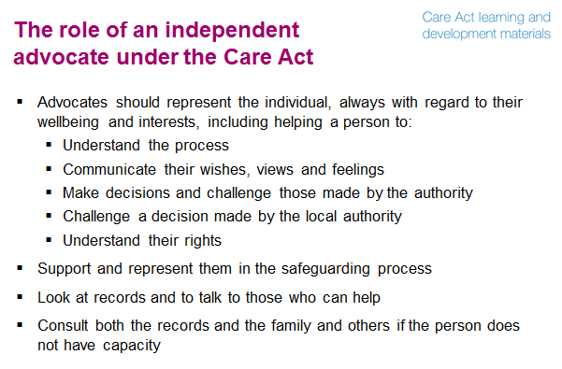
Notes
- An independent advocate is there to support and represent the person for the purpose of facilitating their involvement. The advocate therefore needs to decide the best way of supporting and representing the person they are advocating for, which must be proportionate to the person’s needs and circumstances. This may involve creative approaches, for example, supporting someone to show film to help explain their needs, wishes or preferences.

- No matter how complex a person’s needs, there is a requirement to: involve them and help them express their wishes and feelings, support them to weigh up options, and make their own decisions.

- Acting as an advocate for a person who has substantial difficulty in engaging with care and support or safeguarding processes is a responsible position. It includes supporting a person to:
- understand the key care and support or safeguarding processes and how their needs can be met (by the local authority or otherwise). This requires advocates to understand local authority processes and policies, and other agencies roles, the available assessment tools, the planning options, and the options available at the review of a care or support plan, and good practice in safeguarding enquiries and SARs
- communicate their views, wishes and feelings to the staff who are carrying out an assessment or developing a care or support plan or reviewing an existing plan, or carrying out a safeguarding enquiry or review
- make decisions about their care and support arrangements – assisting them to weigh up various care and support options and to choose the ones that best meet the person’s needs and wishes
- challenge a decision or process made by the local authority; and where a person cannot challenge the decision even with assistance, then to challenge it on their behalf, is the person so wishes
- understand their rights under the Care Act – for an assessment which considers their wishes and feelings and which considers the views of other people; their right to have their eligible unmet needs met, and to have a care or support plan that reflects their needs and their preferences. Also assisting the person to understand their wider rights, including their rights to liberty and family life.

- Note that where assessments are taking place of two people in the same household, if both people agree to have the same advocate, and if the advocate and the local authority both consider there is no conflict of interest, then the same advocate may support and represent the two people. If any of the people involved (the people being assessed or taking part in the care planning, the assessor or the advocate) consider that it would be better to have different advocates then separate advocates should be provided.

- In terms of safeguarding there are some particular important issues for advocates to address. These include supporting a person to:
- decide what outcomes/changes they want
- understand which actions of their own may expose them to avoidable abuse or neglect
- understand what actions that they can take to safeguard themselves
- understand what advice and help they can expect from others, including the criminal justice system
- understand what parts of the process are completely or partially within their control
- explain what help they want to avoid reoccurrence and also recover from that experience

- Where practicable, they are expected to meet the person in private.

- Where a person has capacity, the advocate should ask their consent to look at their records and to talk to those who can help. Family, friends, carers, care and support workers, and others can provide information about their needs and wishes, their beliefs and values.

- Where a person does not have capacity the advocate is required to consult both the records and the family and others if the advocate considers this is appropriate and in the person’s best interests. The guidance states “The Act allows advocates to examine and take copies of relevant records in certain circumstances. This mirrors the powers of an Independent Mental Capacity Advocate” (7.50)
Example
Kate has profound and multiple learning disabilities. She doesn’t use formal communication like words or signs. She communicates using body language and facial expressions. In her assessment, Kate’s independent advocate supports her to show some film of her visiting a local market, enjoying the colours and sounds around her. In this way Kate is able to show the assessor some of the things that are important to her.

Questions
- Do you understand the local authority’s key care and support processes, and policies, the available assessment tools, the planning options, and the options available at the review of a care or support plan?
- Could you explain how the care and support system works and how someone could access it?
- Do you know how to access information and advice about the types and range of care and support services available to local people?
- Do you know what good practice in safeguarding enquiries and SARs is?
- Do you understand the rights, under the Care Act, of people who need care or carers?

Key learning point
The role of the independent advocate is to support and represent the individual and to facilitate their involvement in the key processes and interactions with the local authority.

Facilitator’s hints and tips
Independent advocacy under the Care Act- actively supporting the individual to make the decision for themselves and participate in care planning - may represent a different role or approach for independent advocates. If relevant, this could be explored further with learners. This could include a discussion of how well independent advocates know, and need to know, the local authority’s processes and procedures.
This module could also be combined with extracts from the introduction and overview, assessment and eligibility and care and support planning modules to further explore service user’s and carer’s rights under the Care Act and new duties for local authorities.

Slide 8


Notes
- There will be times when an advocate will have concerns about how the local authority has acted or what decision has been made or what outcome is proposed. At these times the independent advocate must ‘advocate’ on the individual’s behalf and represent their interests.

- Where the individual does not have capacity to challenge a decision, the advocate must challenge any decision where they believe it is inconsistent with the duty to promote the individual’s wellbeing. Where a person is unable to make their own representations or decisions, the advocate must use what information they have and make the representations on behalf of the person. The advocate must scrutinise the options, question the plans if they do not appear to meet all eligible needs or do not meet them in a way that fits with the person’s wishes and feelings, or are not the least restrictive of people’s lives, and challenge local authority decisions where necessary.

- The advocate must write a report outlining their concerns for the local authority.

- The local authority should convene a meeting with the advocate to consider the concerns and then provide a written response.

- The local authority is expected to recognise that an advocate’s role incorporates challenge on behalf of the person, and the local authority must take into account any representations made by an advocate. The local authority must provide a written response to a report from an advocate which outlines concerns about how the local authority has acted or what decision has been made or what outcome is proposed.

- The local authority should take reasonable steps to assist the advocate in carrying out their role. For example they should:
- let other agencies know that an advocate is supporting a person, facilitating access to the person and to the records
- propose a reasonable timetable for the assessment and the care and support plan
- keep the advocate informed of any developments and of the outcome of the assessment and the care and support plan.

- The local authority may make reasonable requests of the advocate for information or for meetings

Key learning point
The independent advocate must ‘advocate’ on the individual’s behalf and represent their interests. The local authority is expected to recognise that an advocate’s role incorporates challenge and should take reasonable steps to assist the advocate in carrying out their role.

Questions
- How do your processes, procedures and systems currently support the involvement of independent advocates?
- What issues, if any, might this raise for you or your organisation?

Slide 9
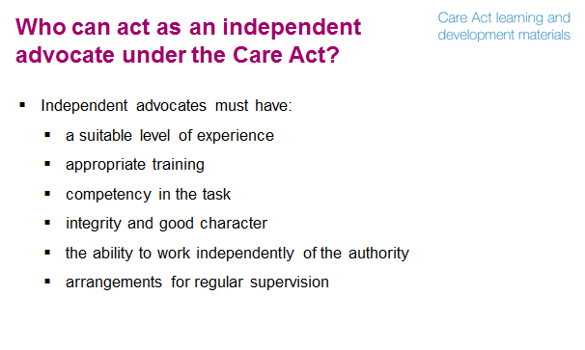
Notes
- Independent advocates must have:
- a suitable level of experience: this may, for example, be in non-instructed advocacy or in working with those groups of people who may have substantial difficulty in engaging with assessments and care and support planning
- appropriate training: this may, for example, initially be training in advocacy (non-instructed or instructed) or dementia, or working with people with learning disabilities. Once appointed, all independent advocates should be expected to work towards the National Qualification in Independent Advocacy (level 3), including the Care Act module currently in development, within a year of being appointed, and to achieve it in a reasonable amount of time
- competency in the task: this will require the advocacy organisation assuring itself that the advocates who work for it are all competent and have regular training and assessments of their competence
- integrity and good character: this might be assessed through: interview and selection processes; seeking and scrutinising references prior to employment and on-going DBS checks
- the ability to work independently of the local authority or body carrying out assessments, planning or reviews on the local authority’s behalf: this would include the ability to make a judgement about what a person is communicating and what is in a person’s best interests, as opposed to in a local authority’s best interests, and to act accordingly to represent this. The advocate must not be working for the local authority, or for an organisation that is commissioned to carry out assessments, care and support plans or reviews for the local authority
- arrangements for regular supervision: this will require that the person meets regularly and sufficiently frequently with a person with a good understanding of independent advocacy who is able to guide their practice and develop their competence.

- The third updated version on the Advocacy Quality Performance Mark (QPM) was published on 3 April 2014 by the National Development Team for Inclusion (NDTi). The QPM is a tool for providers of independent advocacy to show their commitment and ability to provide high quality advocacy services – essential for people to have their voices heard, to exercise choice and control and to live independently.

- Note that the Department of Health has commissioned the development of a new training course in ‘supported decision making’. Independent advocates will be expected to undertake this to enable them to advocate appropriately.

- All local authorities must ensure that there is sufficient provision of independent advocacy to meet their obligations under the Act. There should be sufficient independent advocates available for all people who qualify, and it will be unlawful not to provide someone who qualifies with an independent advocate.

Questions
- Are you appropriately experienced, trained and supported to work as a Care Act independent advocate?
- Are more (or different) people likely to require an independent advocate because they have ‘substantial difficulty’ under the Act than previously accessed advocacy in your local area?
- Does your local authority have a sufficient pool of people who can work as independent advocates under the Act?

Interface with the Mental Capacity Act 2005
Slide 10
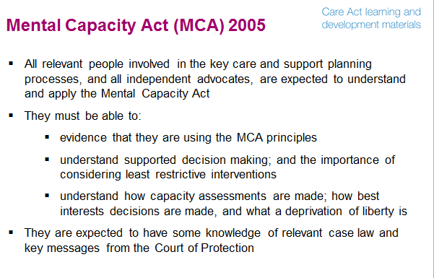
Notes
- The MCA is about protecting and promoting the rights of people where someone is unable to make a decision because of the way their mind or brain works is affected, for instance by illness or disability. The lack of capacity may be temporary because they are unconscious or barely conscious whether due to an accident, being under anaesthetic or as a result of other conditions such as the effects of drugs or alcohol. The lack of capacity may be long term, but still may be enhanced with the right level of support.

- All staff assessing care and support needs, and undertaking care planning and reviews – as well as all Care Act independent advocates - are expected to understand the MCA and to apply it, including understanding how the MCA interfaces with the Care Act. In term of knowledge, they need to understand:
- the five MCA principles:
- every adult has the right to make his or her own decisions and must be assumed to have capacity to make them unless it is proved otherwise
- a person must be given all practicable help before anyone treats them as not being able to make their own decisions
- just because an individual makes what might be seen as an unwise decision, they should not be treated as lacking capacity to make that decision
- anything done or any decision made on behalf of a person who lacks capacity must be done in their best interests
- anything done for or on behalf of a person who lacks capacity should be the least restrictive of their basic rights and freedoms
- how to carry out a mental capacity assessment
- how to make a best interests decision: having supported the person to express their wishes and feelings; having consulted others; and having considered issues such as a person’s liberty and their right to family life
- what a deprivation of liberty is.
Key learning point
All relevant people involved in the key care and support planning processes, and all independent advocates, are expected to understand and apply the Mental Capacity Act.

Slide 11
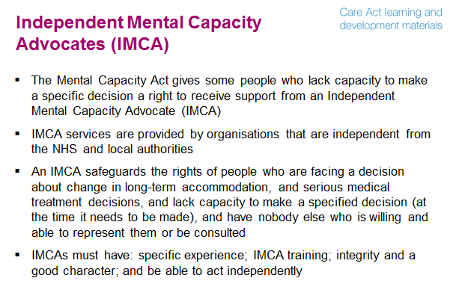
Notes
- The MCA introduced Independent Mental Capacity Advocates (IMCAs). Under the MCA, when people meet the IMCA criteria, local authorities and the NHS have a duty to instruct an IMCA for changes in accommodation and serious medical treatment decisions. For care reviews and adult protection procedures, local authorities and the NHS have powers to appoint an IMCA (where they consider it beneficial).

- IMCAs are independent and work for advocacy providers who are not part of a local authority or the NHS. The MCA requires ‘decision-specific’ assessments of capacity. The IMCA will stop being involved in a case once the decision has been finalised and they are aware that the proposed action has been carried out. They will not be able to provide on-going advocacy support to the person. If it is felt that a person needs advocacy support after the IMCA has withdrawn, it may be necessary to make a referral to a local advocacy organisation.

- The right to an IMCA applies to decisions about long-term accommodation moves to or from a hospital or care home or a move between such accommodations (and serious medical treatment decisions). An IMCA safeguards the rights of people who:
- are facing a decision about a long-term move;
- lack capacity to make a specified decision at the time it needs to be made; and
- have nobody else who is willing and able to represent them or be consulted in the process of working out their best interests, other than paid staff.

- An IMCA cannot be involved if a person has capacity (or the proposed long-term change in accommodation is a requirement under the Mental Health Act 1983).

- Individual IMCAs must:
- have specific experience (related to working with people who need support with making decisions, advocacy experience and experience of health and social care systems)
- have IMCA training
- have integrity and a good character
- be able to act independently.

- They must also understand how to support and represent people who have dementia and learning disabilities, or other mental impairments which mean decision making is impaired.

Slide 12
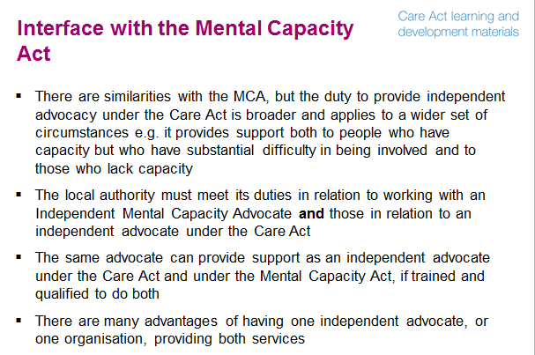
Notes
- There are similarities with the Mental Capacity Act (MCA), however the duty to provide independent advocacy under the Care Act is broader and applies to a wider set of circumstances. The Care Act provides independent advocacy support to:
- people who have capacity, but who have substantial difficulty in being involved in the key care and support processes, as well as those who lack capacity
- people in relation to their assessment and/or care and support planning regardless of whether a change of accommodation is being considered
- people in relation to the review of a care and/or support plan (as a duty not a power)
- people in relation to safeguarding processes (though IMCAs may be involved if the authority has exercised its discretionary power under the MCA)
- carers who themselves have substantial difficulty in engaging whether or not they have capacity
- people for whom there is someone who is appropriate to consult for the purpose of best interests decisions under the MCA, but who is not able and/or willing to facilitate the person’s involvement in the local authority processes.

- The statutory guidance stipulates the role of an independent advocate under the Care Act as being less about informing best interests decisions, and more about actively supporting the person to make the decision for themselves and participate in care planning, and then representing their interests when this is required. The regulations are framed in terms of helping a person to understand and exercise their rights, and also challenging decisions where necessary.

- There are likely to be people who qualify for independent advocacy under the Care Act but not an Independent Mental Capacity Advocate (IMCA). However, most of the people who qualify for independent advocacy under the Mental Capacity Act 2005, in relation to care planning and care review, will also qualify for independent advocacy under the Care Act. Both the Care Act and the MCA recognise the same areas of difficulty but the test with the MCA is whether the person ‘lacks capacity’ to make specific decisions where as the Care Act is having substantial difficulty in being involved in key local authority processes.

- To enable the person to receive seamless advocacy and not to have to repeat their story to different advocates, the same person could provide support as an independent advocate in both roles, if trained, qualified and with the appropriate skills to do both. However, under whichever legislation the advocate providing support is acting, they should meet the appropriate requirements for an independent advocate under that legislation.

- The local authority must meet its duties in relation to working with an IMCA provided under the MCA as well as those in relation to an independent advocate under the Care Act when the independent advocate is acting in both roles.

Key learning point
Both the Care Act and the Mental Capacity Act recognise the same areas of difficulty, but the test with the MCA is whether the person ‘lacks capacity’ to make specific decisions, whereas with the Care Act it is having ’substantial difficulty’.

Questions
- Using your experience, can you think of an example of someone who would meet the ‘substantial difficulty’ criteria but who does not ‘lack capacity’?
- What are the current local arrangements for providing independent advocacy? Will they need to change?
- The regulations have been designed to enable independent advocates to be able to carry out both roles. What are the overlaps in both roles?

In both Care Act and IMCA roles, independent advocates:
- support and represent people
- primarily work with people who do not have anyone appropriate to support and represent them
- require a similar skills set
- must adhere to similar regulations about appointment and training
- will need to be well known and accessible
- may challenge local authority decisions (and local authorities are under a duty to consider representations made by independent advocates in both types of roles).

Facilitators’ hints and tips
There will be situations in which a person could potentially be referred to either an IMCA or an independent advocate under the Care Act (or both). Theoretically, a local authority could appoint one advocate as an IMCA and a different person acting as an independent advocate under the Care Act as the local authority must meet its duties in relation to both sets of legislation: one duty does not ‘trump’ the other. However, this is not likely to be beneficial to either the individual needing advocacy or the local authority. Depending on the audience, it may be useful to explore with learners how they could undertake both advocacy roles, or, whether the local authority might commission an organisation(s) to provide both types of advocacy, and the advantages of doing so.

In general, advocacy should be seamless for people who need it, so that they can benefit from the support of one advocate for their whole experience of care and support or safeguarding. It rarely makes sense to have one advocate for assessment and another for care and support planning.

When the Care Act independent advocacy duties apply
Slide 13
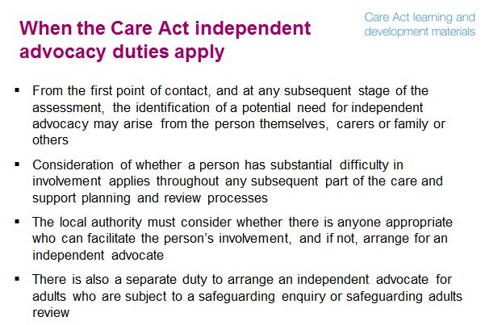
Notes
- At the start of the assessment process, which begins at first contact, if it appears that a person has care and support needs the local authority must judge whether a person has substantial difficulty in involvement. Where an authority has outsourced or commissioned all or some of this process, the authority will maintain overall responsibility for this judgement.

- The same applies throughout any subsequent part of the care and support planning processes after assessment or any following review. This applies regardless of whether an advocate was involved at an earlier stage. For example because:
- The person’s ability to be involved in the process without an advocate has changed.
- The circumstances have changed (e.g. the person’s involvement was previously facilitated by a relative who is no longer able to perform that role).
- An advocate should have been involved at the care and support planning stage and was not.
- The requirement to involve an advocate at the care and support planning stage did not exist at that time.

- The duty to involve applies in all settings, including those people living in the community and in care homes, and also in prisons for example. It applies equally to those people who needs are being jointly assessed by the NHS and local authority or where there is a joint package of care with the CCG.

- Note that subject to further consultation, the duty would also apply - from April 2016 – if an individual made an appeal against a local authority decision (made under Part 1 of the Care Act).
- The local authority must consider whether there is anyone appropriate who can support the person to be fully involved e.g. family member or friend – and if not, arrange for an independent advocate.

- There is also a separate duty to arrange an independent advocate for adults who are subject to a safeguarding enquiry or safeguarding adults review (SAR).
- The local authority must arrange, where necessary, for an independent advocate to support and represent an adult who is the subject of a safeguarding enquiry or a SAR. Where an independent advocate has already been arranged under s67 Care Act or under the Mental Capacity Act, unless inappropriate, the same advocate should be used.
- If a safeguarding enquiry needs to start urgently then it can begin before an advocate is appointed, but one must be appointed as soon as possible. All staff and agencies need to know how the services of an advocate can be accessed and what their role is.

Question
- How will you ensure that consideration of substantial difficulty will be made at the point of first contact, an assessment, and throughout the subsequent care and support planning and review processes? Will this consideration need to be recorded, and if so how?
- What might be the implications of the need to involve an independent advocate at the review stage for people who do experience substantial difficulty, but for whom an advocate was not involved earlier because the requirement did not exist?

Key learning point
The duty to provide independent advocacy applies at the point of first contact , through assessment and throughout any subsequent part of the care and support planning oand review process. There is also a separate duty to arrange an independent advocate for adults who are subject to a safeguarding enquiry or safeguarding adults review.

Facilitators hints and tips
It is critical in the particularly sensitive area of safeguarding (whether an enquiry or a SAR) that the individual is supported in what may feel a daunting process which may lead to some very difficult decisions. If relevant to the audience, it may be useful to explore with learners how they could best support an individual who is thought to have been abused or neglected – who may be so demoralised, frightened, embarrassed or upset that independent advocacy to help them be involved will be crucial.

Slide 14
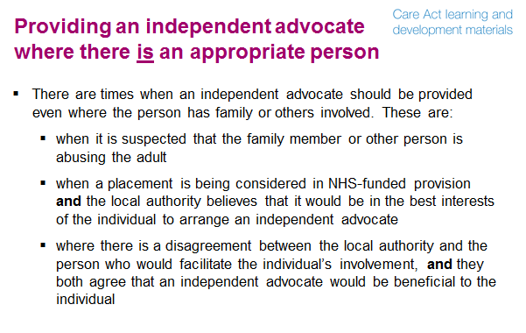

Notes
- In general, a person who has substantial difficulty in being involved will only become eligible for an advocate where there is no one appropriate to support their involvement. However, the provision of an advocate, even where they have family or others who can facilitate the person’s involvement, is appropriate in these circumstances:
- if it has already been established that a family member has abused the adult then they will automatically be excluded from advocating for them, however, if there are suspicions that they may be abusing or placing the adult at risk of harm, then it is reasonable to exclude them from acting as that person's advocate until the full facts have been established
- where a placement is being considered in NHS-funded provision in either a hospital (for a period exceeding four weeks) or in a care home (for a period of eight weeks or more) and the local authority believes that it would be in the best interests of the individual to arrange an advocate
- where there is a disagreement between the local authority and the appropriate person whose role it would be to facilitate the individual’s involvement, and the local authority and the appropriate person agree that the involvement of an independent advocate would be beneficial to the individual.

Questions
- What things do you think you might have to consider in these circumstances?

Summary
Slide 15
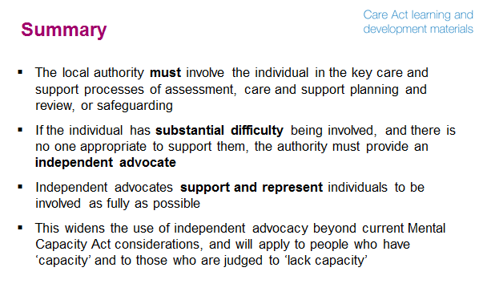
Questions
- What has struck you most about this session?
- Thinking about what you have learnt about independent advocacy (and on any other modules you have completed so far).......
- What links can you make between topic areas?
- How might the necessary changes impact on your current arrangements?
- What might the key challenges be?

Exercise
- What are your top three priorities in relation to independent advocacy?
- Complete the action plan to identify the next steps for each priority.
Appendices

Links to key resources
Action for Advocacy (2006) Quality Standards for Advocacy Schemes. Quality Standards for Advocacy Schemes is a product of the Charter in Action programme initiated by AfA in 2005. It consists of two main elements: firstly, a series of evidence-based quality standards for advocacy organisations and secondly, a code of practice for advocates. It also includes a series of training exercises designed to support groups in thinking through the issues involved in adopting the standards. Although AfA, the leading umbrella organisation for the advocacy sector in England and Wales has now closed the documents remain available
Advocacy Quality Performance Mark (2014) Advocacy Code of Practice. The advocacy code of practice and advocacy charter (2002) are available to download from the Advocacy QPM website, which enables advocacy providers to demonstrate how they are meeting the standards set out in the code.
Assist Advocacy Services in Staffordshire (no date). The Watching Brief: Working with advocates using Non-Instructed Advocacy
Bauer A, Dixon J, Wistow G & Knapp M (2013) Investing in Advocacy for Parents with Learning Disabilities: What is the Economic Argument? Discussion Paper 2860, London School of Economics. This review investigates some of the costs and outcomes of advocacy provided to parents with learning disabilities at risk of losing their children into care.
Brown G, Standen N, Khilji B (2013) Dementia Advocacy in a Time of Austerity, Coventry University, Coventry. The study draws attention to the benefits of advocacy as a means of supporting older people with dementia and illuminates internal and external challenges encountered by third sector organisations providing this type of support.
Change UR Mind Transitions Advocacy Project Available at http://www.changeurmind.org.uk/projects/8/transitions-advocacy-project (Accessed 26 August 2014). A project delivered by Youth Focus: North East in partnership with YoungMinds, and is funded by the Clinical Innovations Team (NHS North East). The site includes a service directory and case study material, some of which has been sourced from the Young Minds website.

Dementia Advocacy Network and Advocacy Plus (2012) Taking Their Side: Fighting Their Corner 16 Stories Demonstrating the Difference Independent Advocacy Makes to the Lives of People with Dementia, DAN, London. This book is a collection of stories about the contribution made by advocates working in different organisations and different settings including care homes, hospitals and in the community, from across the UK. The stories are written from the perspective of the advocate, with some comments from people with dementia themselves. Although the network has now closed this resource is still available.
Department for Constitutional Affairs (2007) Mental Capacity Act 2005 Code of Practice. London: The Stationery Office. The Code of Practice supports the mental Capacity Act (MCA) and provides guidance to all those who care for and/or make decisions on behalf of adults who lack capacity. The Code includes case studies and clearly explains in more detail the key features of the MCA.
Empowerment Matters Resources Available at http://www.empowermentmatters.co.uk/?page_id=74 (no date) (Accessed 21 October 2014). This website contains a wealth of resources focusing on good practice in advocacy for advocates including: Making financial decisions: Guidance for assessing, supporting and empowering specific decision making.
Equality and Human Rights Commission (2010) Research Report 67 Advocacy in social care for groups protected under equality legislation. The purpose of this study was to assess the extent to which existing advocacy provision is available for people in the groups protected by equality legislation.
Equalities National Council (2012) Stop, Look and Listen: A Manifesto for Change and Inclusion of Black and Minority Ethnic Disabled People, Their Carers and Families. A BME user-led Disabled People Organisation, committed to developing advocacy services and community programmes.
Franklin A, Knight A (2011) Someone on our Side: Advocacy for Disabled Children and Young People. This report, published by The Children’s Society Research Unit contains the findings and recommendations of a review into advocacy arrangements for children and disabled young people across England.
Horton C (2009) Creating a Stronger Information, Advice and Advocacy System for Older People, Joseph Rowntree Foundation Solutions, York. This paper is based on development work in Newcastle on improving ways of working with existing systems to make them more 'older person friendly', efficient, and effective for all concerned. Practical improvement learning is derived from initiatives within the Newcastle Advocacy Centre and local partnerships.

IRISS (2013) Advocacy: Models and Effectiveness The Institute for Research and Innovation in Social Services (IRISS). A concise research and practice review on the development and practice of advocacy in the UK. It draws on evidence in relation to advocacy with both children and adults and on literature from the fields of health and social care. The review outlines key elements to the most prevalent models of advocacy and identifies good practice, as well as the limitations of advocacy models.
Lawton A (2009) Personalisation and Learning Disabilities: A Review of Evidence on Advocacy and its Practice for People with Learning Disabilities and High Support Needs. SCIE Report 24, London. This review identified a lack of robust ‘published’ research on the impact of advocacy and called for more research so that better estimates of cost-effectiveness and impact can be made.
Macadam A, Watts R and Greig R. (2013) The Impact of Advocacy for People who Use Social Care Services. NDTi/ NIHR School for Social Care Research Scoping Review. This review is derived from an evaluation of the impact of advocacy and finds an overall lack of robust evidence particularly in terms of its cost-effectiveness.
Rethink Mental Illness (2013) Advocacy. This factsheet forms part of an online resource that explains what advocacy is, why an advocate might be needed and how to find one.
Royal College of Psychiatrists (2012), Independent Advocacy for People with Mental Disorder, Royal College of Psychiatrists, London. This report updates and replaces an earlier document published by the RCP and provides information on what independent advocacy is and why it is needed.
Social Care Institute of Excellence (2010). SCIE Guide 31: Good practice guidance for the commissioning and monitoring of Independent Mental Capacity Advocate services. SCIE have a resource page for IMCAs.
Social Care Institute of Excellence (2009). At a glance 12: Personalisation briefing: Implications for advocacy workers.
Townsley R, Marriott A and Ward L (2009) Access to Independent Advocacy: An Evidence Review. Office for Disability Issues. This review draws on evidence related to people with mental health support needs, people with learning disabilities and people with physical/sensory impairments to evaluate the need, benefits and costs associated with independent advocacy for disabled people.
Newbigging K et al (2012) The Right to be Heard: Review of Independent Mental Health Advocate (IMHA) Services in England, University of Central Lancashire.

The following links to other legislation might also be useful:
Mental Capacity Act 2005 http://www.legislation.gov.uk/ukpga/2005/9/contents
Data Protection Act http://www.legislation.gov.uk/ukpga/1998/29/contents
Human Rights Act http://www.legislation.gov.uk/ukpga/1998/42/contents

Handouts
Handouts, exercises and case studies relevant to this topic area:
- Handout: Substantial difficulty
- Case Study: Mishal
- Case Study: Adam

